
VersaKey Programmable _____
Selling Sheet
Overview

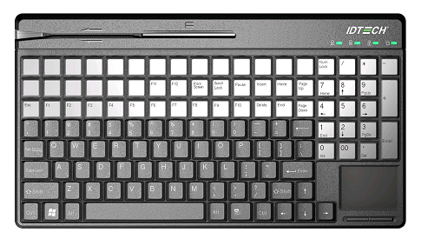
On behalf of ID TECH, we are pleased to introduce our newest member in the POS keyboard family – VersaKey Programmable

The VersaKey™ Programmable Keyboard is a plug-and-play peripheral device that is derived from the same core technologies found in ID TECH’s top selling magnetic stripe reader, the MiniMag™. By using the included KeyUtility software, also developed by ID TECH, users can customize up to 60 programmable keys, allowing for fewer keystrokes and greater efficiency. The VersaKey™ Programmable Keyboard integrates a fully-functional keyboard with an optional touchpad mouse, and both magnetic stripe and smart card readers into a single, compact device

Feature Bullet Points

- 124/135 key layout in a compact 14” form factor
- Up to 60 programmable and re-legendable keys
- Programmable keys and magnetic stripe reader are configured through the utility software provided
- Standard Microsoft keyboard layout with LED indicators
- Reliable to 20 million keystrokes and 1 million card swipes cycles
- Smart card reader option
- Optimal EMV level 1 approved smart card reader
- Optional touchpad for simple cursor navigation
- Multiple language keyboard layouts upon request

Target Market

The VersaKey Programmable has its target market in the distribution channel and end user. It is positioned to compete with Cherry and Unitech with its competitive price point, compact size keyboard, magnetic stripe reading, smart card reading, and programmable key features.

Lead time

The Standard Lead time of this product is 6-8 weeks for normal orders (depending on stock availability) and 8-10 weeks for orders over 500 units.
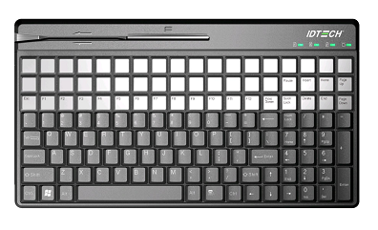
Pricing

Model # | Description | List Price
IDKA-334533B | VersaKey Compact; Mag Rdr; 3T; Programmable; w/ touch pad; USB | $248.00
IDKA-354500B | VersaKey Compact; Smt; Programmable; w/ touch pad; USB | $358.00
IDKA-384533B | VersaKey Compact; Mag Rdr & Smt; 3T; Programmable; w/ touch pad; USB | $428.00
IDKA-334433B | VersaKey Compact; Mag Rdr; 3T; Programmable; w/o touch pad; USB | $228.00
IDKA-354400B | VersaKey Compact; Smt; Programmable; w/o touch pad; USB | $338.00
IDKA-384433B | VersaKey Compact; Mag Rdr & Smt; 3T; Programmable; w/o touch pad; USB | $408.00

Comparison

Compared to its competition, the VersaKey Programmable is highly competitive among the market leaders in the POS keyboard industry.

Manufacturer | ID TECH | Cherry | Unitech | Logic Control | Preh KeyTech
Model Number | IDKA-3XXXXX | SPOS G86 | KP3800 | LK8000 | MC 128
Interface(s) | USB | USB | PS2, USB | USB, PS2, RS232 | PS2
Color | Black | Black or Light Grey | Black or Ivory | Black | Black or White
Number of Keys | 135/124 | 123 | 100 | 122 | 128
Dimension | 14” x 8” x 1.7” | 14” x 8” x 1.625” | 17.5" x 6.75" x 1.375" | 17.36" x 8.5" x 2.13" | 13.19" x 9.61" x 2.17"
Dimension | 360 x 198 x 43mm | 360 x 198x 38mm | 445 x 171 x 35mm | 441 x 214 x 54mm | 335 x 244 x 55mm
Operating Temperature | 0 ºC – 50ºC | 0 ºC – 50ºC | 0 ºC – 55ºC | 0 ºC – 50ºC | 0 ºC – 50ºC
Storage Temperature | -20 ºC – 60ºC | -20 ºC – 60ºC | -20 ºC – 55ºC | -20 ºC – 60ºC | -40 ºC – 60ºC
Key pad Operating cycle | 20 Million | 25 Million |  | 50 Million | > 3 Million
MSR Operating cycle | 1,000,000 pass Min. | 1,000,000 pass Min. | 300,000 pass Min. | 1,000,000 pass Min. | 300,000 pass Min.
Touch pad | Yes | Yes | Yes | Yes
Total Key count | 124 | 124 | 100 | 122 | 128
Programmable Keys | One layer | All Keys up to 3 layers | All Keys up to 3 layers | All Keys up to 3 layers | All Keys up to 3 layers
Relegendable Keys | Yes (54/60) | 54 | 84 | 46 | 128
Warranty | 1 years | 2 years | 1 year for the main unit  90 days for cable | 1 year
Pricing | $248 | $234 | $450 | $280 | $308
Unique Features/Benefits | ● Configuration software  ● Compact size  ● With smart card reader option in small form factor | ● Smallest foot print in full function POS keyboards  ● Remote Network Installation |  | ● Patented Wedge Port for barcode scanner  ● Programming Key lock switch | Key exchange technique

Model Number
IDKA-33xxxx

 | X | X | X | X
 | Type | Technology | Interface | Features
0
1 |  |  |  | Standard - 104 key (Full Size only)
2 | Full size Kybd
3 | Compact | MagStripe Rdr | PS/2 Keyboard | Compact, non-programmable
4 |  |  | USB-KyBd | Compact, programmable **
5 |  | Smart Card Rdr * | USB-HID | Compact, programmable, touchpad **
6 |  |  |  | Compact, programmable, trackball **
7
8 |  | MagStripe/Smart Card *
9

Collateral Materials:
- Quickstart Manual
- User Manual
- Datasheet

Warranty
ID TECH warrants to the original purchaser of the VersaKey Programmable for a period of 12 months (1 years) from the date of invoice.

